**Data Type**

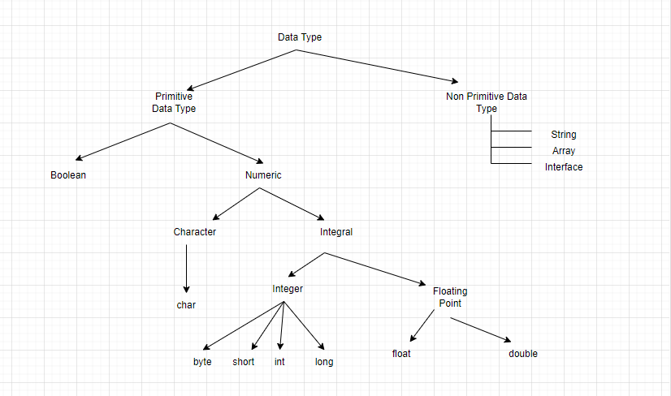

**Primitive Data Type**

|  |  |  |
| --- | --- | --- |
| **Data Type** | **Default Value** | **Default Size** |
| boolean | FALSE | 1 bit |
| char | \u0000' | 2 byte |
| byte | 0 | 1 byte |
| short | 0 | 2 byte |
| int | 0 | 4 byte |
| long | 0L | 8 byte |
| float | 0.0f | 4 byte |
| double | 0.0d | 8 byte |

**Non-Primitive Data Type : -**

1. **Non- Primitive data types are user defined data type**
2. **With Non-primitive data type, we can perform actions**
3. **With Non-primitive data type, we can create object**
4. **Non-Primitive start from upper case where primitive data type start from lower case**
5. **Class –**
6. **Class is a user defined data type that is used to create an object**
7. **A class contains a set of properties, methods.**

**There are various components in a class**

1. **Access Modifier**
2. **Class Name**
3. **SuperClass**
4. **Interfaces**
5. **Body and Members**

**Example**

1. Class has a name as Demo  
class Demo {   
 int res = 100;   
 Demo() {   
 System.out.println(res);  
 }  
 public void add(int a, int b) {   
 int c = a + b;  
 System.out.println("Addition of numbers: " + c);  
 }  
 public void sub(int a, int b) {   
 int c = a - b;  
 System.out.println("Subtraction of numbers: " + c);  
 }  
}  
  
public class Main {  
 public static void main(String[] args) {  
 Demo obj = new Demo();  
 obj.add(10, 20);  
 obj.sub(50, 25);  
 }  
}

**Points to note:**

1. **Class has name as Demo**
2. **It has Class member variable as res**
3. **It has default constructor as Demo()**
4. **It has class member function as add(), sub()**
5. **It has access modifier as public**
6. **String :-**
7. **String is designed in such a way that they can hold the sequence of characters in a single variable.**
8. **Syntax of String is**

**String <variable_name> = “<sequence of characters>”;**

**Or**

**String str1 = new String(“<sequence of characters>”);**

**Methods in the String are:-**

1. **Concatenate**
2. **Length()**
3. **charAt**
4. **replace**
5. **substring**
6. **Array:-**
7. **Array is a non-primitive data type that is used to store the elements of same dat type.**
8. **The declaration of array is**

**datatype[] marks = new datatype[size of array]**

**int[] marks= new marks[3]**

**Store element in array**

**marks[0]=95;**

**marks[1]=96;**

**marks[2]=97;**

**System.out.println(marks[0])**

1. **If we know the value of element then we can initialize array as**

**Int[] marks={98,67, 68};**

1. **The method used for Array is**

**Length, sort();**

**To sort the arry we will Arrays class which has the sort() method**

1. **Let us suppose we have to store the marks of 2 students, then we will initialize the array as**

**Int[][] marks= {{23,78,65},{89,76,89}};**

**System.out.println(marks[1][1]);**